Crest Teeth Whitening Strips Professional Effects – Advanced Whitening for a Brighter Smile

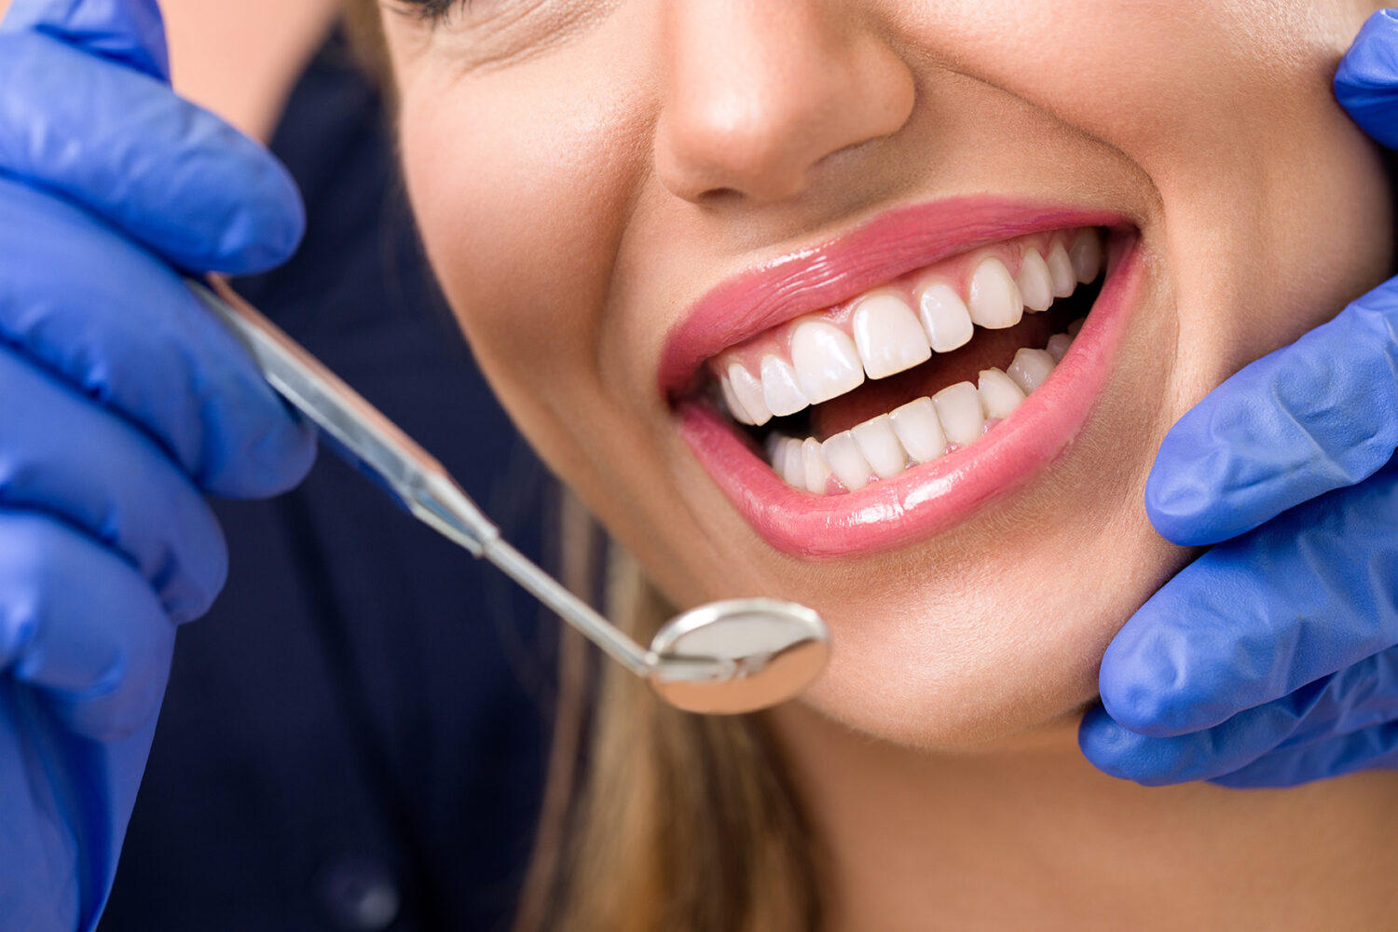

Get a visibly whiter smile with [Crest Teeth Whitening Strips Professional Effects](https://thewhitesmiles.com/shop/crest-whitening-strips-professional/), a professional-grade at-home whitening system that millions of people trust. These professional-grade whitening strips work to erase years of stubborn stains from coffee, tea, wine, and cigarettes, all without leaving your house.

Crest Professional Effects strips feature Advanced Seal Technology with a no-slip hold that is secure as you go about your day. The whitening formula employed is enamel-safe and the same active ingredient as dentists use to provide safe and effective whitening without harming teeth. Daily use will produce visible results after three days with the full effect of whitening being realized within 20 days.

It is easy to use Crest Professional Effects Whitestrips. Simply peel, apply, and wait 30 minutes. The strips conform to your teeth and deliver even whitening without the mess of gels or trays. Excess gel can be rinsed off after removal, leaving your teeth clean and fresh.

These whitening strips are perfect for individuals who want long-term, professional-grade whitening without the hefty price tag. Getting ready for a special occasion or having whiter teeth all year round, Crest Professional Effects is an easy and efficient way to get it.

Try Crest Teeth Whitening Strips Professional Effects and enjoy a dazzling, confident smile today!