How to Become a Vendor at Hometown Vendor Market and Grow Your Local Business

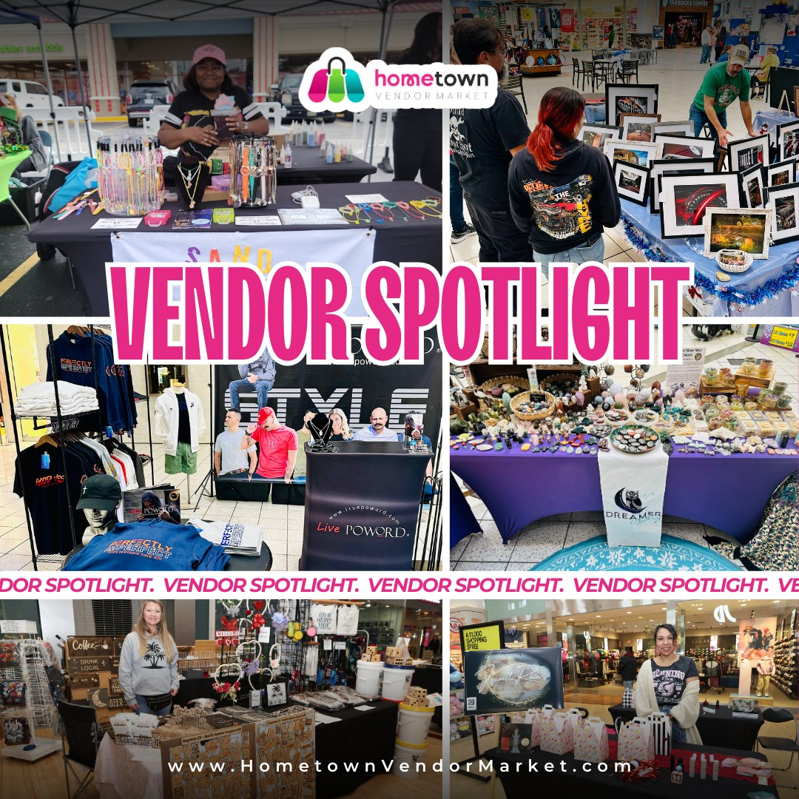
For local makers, small business owners, or creative entrepreneurs looking to connect within their community or build their reach, the Hometown Vendor Market is a great place to begin. Hometown Vendor Market, a curated indoor and outdoor marketplace, celebrates the local maker, creativity, and craftsmanship, by providing a lively venue to share and sell unique product offerings.
Have you been wondering how to become a vendor at Hometown Vendor Market? It really is easier than you think - and very rewarding too. The application process is intended to let your passion and product offerings shine, enabling organizers to curate a visually balanced and diverse market experience. Whether you make handmade jewelry, artisanal food, boutique fashion, home décor, wellness products, or your artwork, Hometown Vendor Market is a great point of departure for visibility and connection.
It is also important to understand that being a vendor means you are more than set up a booth. It means you are part of an ecosystem that values community, creativity and quality. Customers come to the market knowing they can expect originality and charm, and vendors, deliver, with love, care and connection that mass produced will never deliver.
Along with gaining exposure to hundreds (even thousands) of potential customers at each event, vendors also get fantastic community marketing, event marketing and unbeatable opportunities to network with fellow creators and business owners. It's an incredible place to build brand awareness and customer loyalty in a warm and inviting atmosphere.
Being become a vendor at Hometown Vendor Market starts with your passion and culminates at your place in a family of very similar entrepreneurs. Apply today, and take the next step in transforming your creative venture into a successful local business. Let your products shine in a marketplace that celebrates genuineness, quality and community.

